1) Consider a case, a folder has multiple files and how would copy it to destination
machine path
Sol:

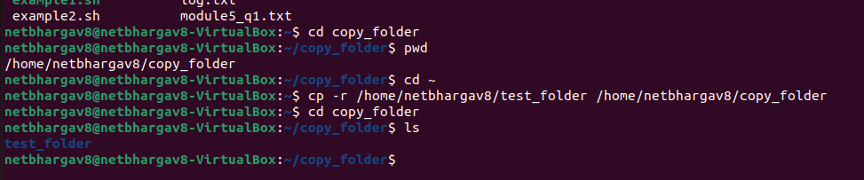
SCP securely transfers files using SSH encryption. It is commonly used to copy directories between
Linux systems or between Windows and Linux machines when SSH is enabled.

Cp -r also can be used to do this

2) Host a FTP and SFTP server and try PUT and GET operations

Sol:

SCP securely transfers files using SSH encryption. It is commonly used to copy directories between
Linux systems or between Windows and Linux machines when SSH is enabled.

The syntax:
ftp <server_ip>

SFTP (Secure File Transfer Protocol) is a secure alternative that operates over SSH. It can be
accessed using:

PUT OPERATION:
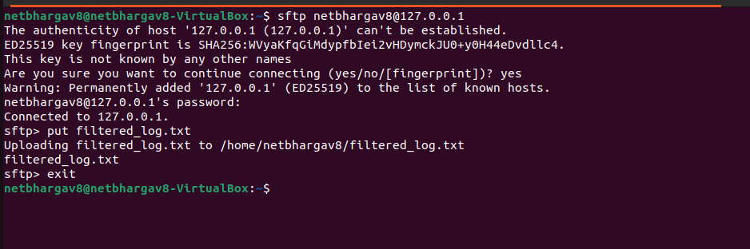

GET OPERATION:

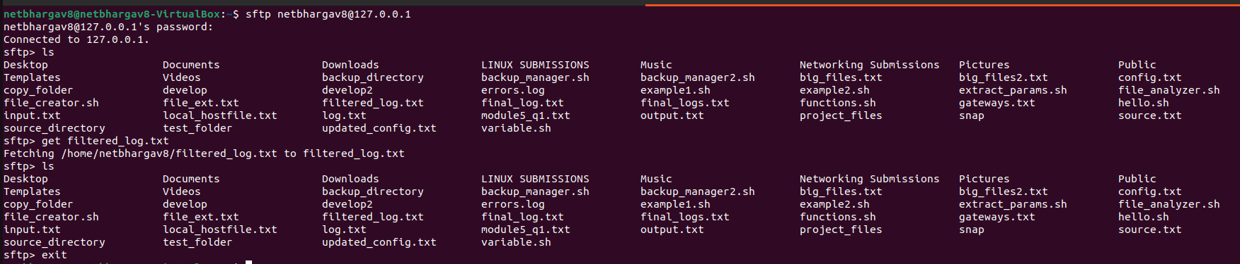

3. Exploring Network Packets Using Wireshark / TCPdump
Wireshark and tcpdump are packet analysis tools used to monitor network traffic.

Using tcpdump in Linux:

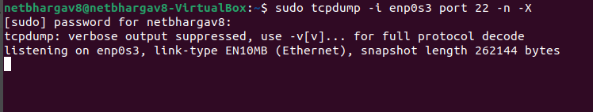

4. Understanding Linux Networking Commands (ping, arp, ifconfig)

PING:
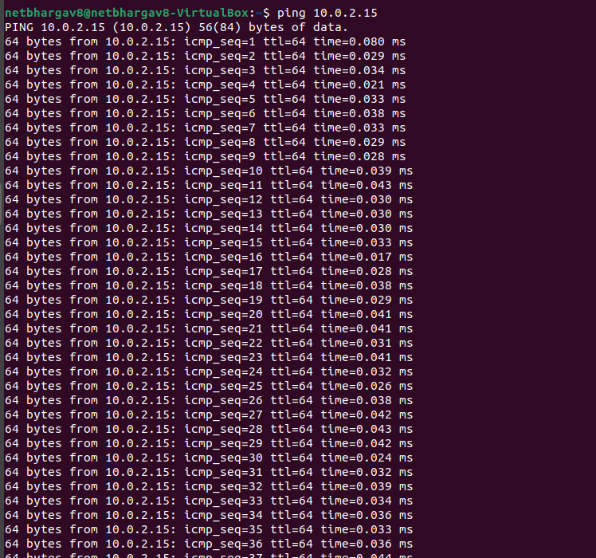
The ping command sends a small packet of data (an ICMP Echo Request) to a specific IP address or domain to verify if it is reachable. It measures the "Round Trip Time" in milliseconds, helping you troubleshoot network latency or connection stability between your device and the server.

ARP:

The arp -a command displays the current entries in your Address Resolution Protocol (ARP) cache, which maps known IP addresses to their corresponding physical MAC addresses. This allows you to see which local devices your machine has recently communicated with on the network.

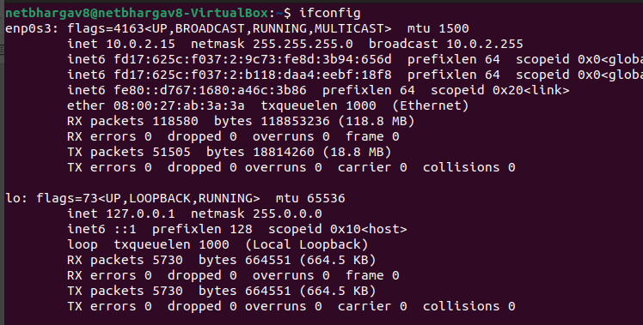

The ifconfig or ip addr command shows:
• IP address
• Subnet mask
• Broadcast address
• MAC address
• MTU
• Interface status
These commands are essential for network troubleshooting.
the ifconfig command is being used to display the active network interface configurations for your virtual machine. It specifically identifies two interfaces: enp0s3, which is your primary Ethernet adapter with the IP address 10.0.2.15, and lo, your local loopback interface at 127.0.0.1.

5. What Happens When Duplicate IP Addresses Are Configured

When two devices on the same network are assigned the same IP address, an IP Address Conflict occurs, causing the network to become unable to reliably deliver data. Since routers and switches use IP addresses to identify unique destinations, a duplicate address causes "flapping" in the ARP table as the network constantly switches between the two physical MAC addresses. This results in intermittent or total connectivity loss for both devices, as the router cannot determine which hardware should receive incoming packets.
Most modern operating systems, including Linux, detect this during the boot process using Gratuitous ARP and will display a "Duplicate IP" warning to the user. To resolve this, network administrators typically rely on DHCP to automatically manage a pool of unique addresses and prevent manual configuration errors. If static IPs are required, the conflict must be manually resolved by reconfiguring one device with a unique address within the correct subnet to restore stable communication.
6. Accessing Remote Systems Using VNC, AnyDesk, TeamViewer, and RDP

Remote systems can be accessed using:
• VNC (port 5900)
• RDP (port 3389)
• AnyDesk / TeamViewer (cloud-based remote access)
RDP can be accessed in Windows using:
mstsc
VNC requires a VNC server on the remote machine. AnyDesk and TeamViewer provide remote access
via unique IDs and do not require manual port configuration.
These tools allow remote desktop control over local or internet networks.

7.How to check your default gateway is reachable or not

To check if it is reachable:
ping <gateway_ip>
If the gateway responds, it confirms that routing to external networks is possible. The default
gateway acts as the router that forwards traffic outside the local subnet.

8. Checking Interface Speed, MTU, and Network Parameters

Ip link show:
This displays the MTU value (usually 1500 bytes).

Sudo ethtool:
Shows network speed

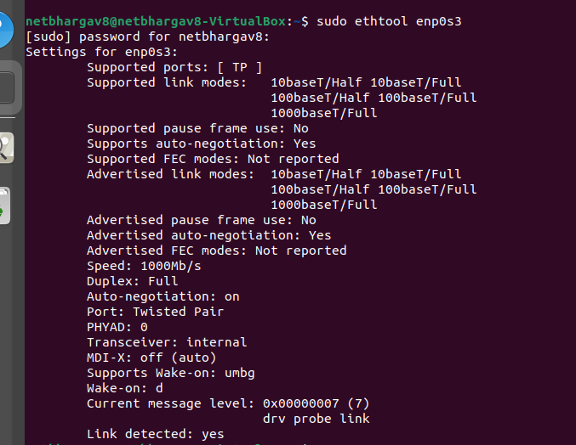
This shows:
• Speed (e.g., 1000Mb/s)
• Duplex mode
• Link detected status
These parameters help determine network performance and diagnose issues such as fragmentation
or slow connectivity.

9. Logging into Router Web Interface and Checking Connected Devices

The router IP is identified using:
ip route (Linux)
The default gateway IP (e.g., 192.168.1.1 or 172.20.24.1) is entered in a browser:
http://<gateway_ip>
After logging in with router credentials, the connected devices list can be viewed under sections like:
• DHCP Client List
• Connected Devices
• LAN Clients

10. How DHCP Assigns IP Addresses

DHCP automatically assigns IP addresses using the DORA process:
1. Discover – Client broadcasts request.
2. Offer – Server proposes an IP address.
3. Request – Client accepts the offered IP.
4. Acknowledge – Server confirms assignment.
The DHCP server also provides subnet mask, default gateway, DNS server, and lease time. This
prevents IP conflicts and simplifies network configuration.
DHCP (Dynamic Host Configuration Protocol) is a network protocol that automatically assigns IP
addresses and other network configuration parameters to devices when they connect to a network.
It works using a four-step process called DORA: first, the client sends a Discover message as a
broadcast to find a DHCP server; the server responds with an Offer containing an available IP address
along with subnet mask, default gateway, DNS server, and lease time; the client then sends a Request
message accepting the offered IP; finally, the server sends an Acknowledge (ACK) confirming the
assignment. The IP address is given for a specific lease period and must be renewed before
expiration. In your hostel network, the router (172.20.24.1) acts as the DHCP server and
automatically assigned your system the IP address 172.20.24.199 along with its subnet mask and
gateway, eliminating the need for manual configuration and preventing IP conflicts.

